GEAR.HR — Architectural Overview

GEAR.HR is a layered desktop application built with Java Swing. It manages employees, attendance, leave, payroll, user credentials, and IT tickets. This document describes our target architecture: primary persistence is MySQL via JDBC, with HM3 payroll expansion (pay periods, batch runs, frozen snapshots, audit, reports). CSV files under csv/ remain as legacy seed/fallback during migration.

The UI adapts navigation and permissions by role group (HR, Payroll, IT/Admin, or normal employee).

1. Architectural style

The codebase follows a classic three-tier layout adapted for a single-process desktop app:

Layer | Package | Responsibility
Presentation | ui | Swing screens, forms, tables, navigation; calls services through ApplicationContext
Business / application | service | Use cases, validation orchestration, auth, payroll computation, role mapping
Persistence | repository | Load/save domain data to MySQL via JDBC; no business rules. DatabaseConnectionManager supplies connections; *JdbcRepository implements I*Repository. CSV repos optional fallback.
Domain | model | Entities, value objects, Identifiable / Validatable contracts
Cross-cutting helpers | util | Stateless validation and payroll math used by model and service layers

There is no network API for HR use cases (desktop-only). Target: a local or course MySQL database accessed through JDBC. The composition root [ApplicationContext](../src/service/ApplicationContext.java) will wire JDBC repository implementations by default (planned); services and UI depend on I*Repository interfaces only (manual dependency injection).

2. Layer Diagram
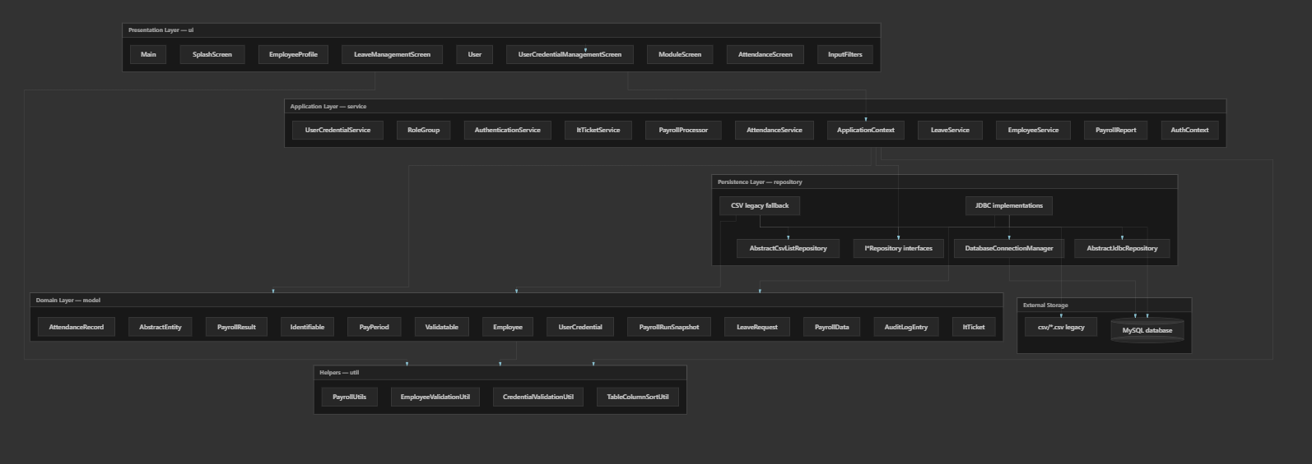

Dependency rule: ui → service → repository → model. util is depended on by model, service, and ui but does not depend on them. repository does not depend on service or ui.

3. Package structure

GEAR.HR/
├── csv/ # Legacy seed data (6 CSV files); optional fallback
├── sql/ # (Planned) schema.sql, migration scripts
├── docs/ # Documentation
├── src/
│ ├── model/ (~13 types) Domain + PayPeriod, PayrollRunSnapshot, AuditLogEntry
│ ├── repository/ (~28 types) I*Repository + JDBC repos + CSV legacy + connection mgr
│ ├── service/ (~17 types) Services, ApplicationContext, RoleGroup enum
│ ├── ui/ (10 types) Screens, Main, ModuleScreen, InputFilters
│ └── util/ (4 types) Validation, payroll formulas, table sorting
└── README.md

Entry point: [Main.main](../src/ui/Main.java) → splash → login → role-based dashboard.

4. Component diagram (major types)
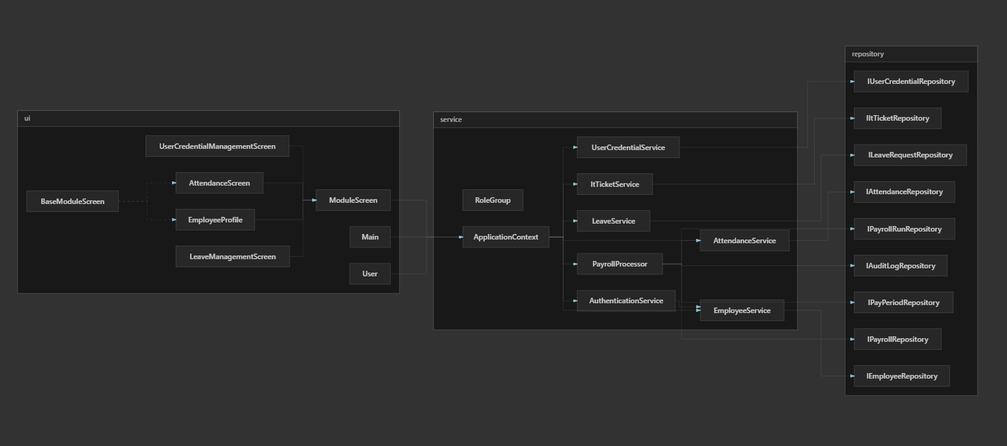

ApplicationContext is the only place that instantiates repositories and services. UI classes receive ApplicationContext via ModuleScreen.show(...) or login/dashboard helpers.

5. Persistence architecture

Target: MySQL (primary)

Table (planned) | Repository | Domain type
employees | EmployeeJdbcRepository | Employee
attendance_records | AttendanceJdbcRepository | AttendanceRecord
leave_requests | LeaveRequestJdbcRepository | LeaveRequest
payroll_settings | PayrollJdbcRepository | Map<String, PayrollData>
user_credentials | UserCredentialJdbcRepository | UserCredential
it_tickets | ItTicketJdbcRepository | ItTicket
pay_periods | PayPeriodJdbcRepository | PayPeriod
payroll_run_snapshots | PayrollRunJdbcRepository | PayrollRunSnapshot
audit_log | AuditLogJdbcRepository | AuditLogEntry

DatabaseConnectionManager opens JDBC connections to MySQL. Concrete repositories extend AbstractJdbcRepository (template for shared query/row-mapping); subclasses implement entity-specific SQL.

Composition root: ApplicationContext wires JDBC implementations by default. An optional flag may select CSV repos during migration.

Transactions (provisional): coordinated commits on saveAllForPeriod and finalizePeriod so snapshots and period status stay consistent.

Repository pattern (JDBC)

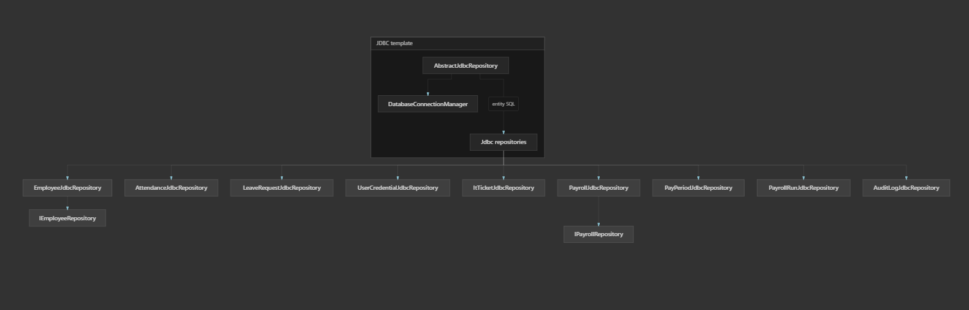

Services call I*Repository only; they do not know whether JDBC or CSV is wired.

6. Service layer (use cases)

Service | Primary responsibility | Key dependencies
AuthenticationService | Load credentials, authenticate user, resolve AuthContext | EmployeeService (implicit via employee lookup)
EmployeeService | CRUD employees, CSV sync, duplicate checks | IEmployeeRepository, IUserCredentialService
AttendanceService | Attendance CRUD, monthly hours for payroll | IAttendanceRepository
LeaveService | Leave requests, overlap checks, status updates | ILeaveRequestRepository
PayrollProcessor | Load/save payroll map, compute PayrollResult using attendance hours | IPayrollRepository, IAttendanceService
UserCredentialService | Admin credential CRUD, sync with new employees | IUserCredentialRepository, IAuthenticationService
ItTicketService | IT ticket CRUD | IItTicketRepository
PayrollReport | Format PayrollResult; (planned) register and deduction summary from snapshots | (static helper, no state)

Payroll computation flow (draft period): UI → PayrollProcessor.getPayrollForEmployee → load PayrollData + attendance hours → PayrollUtils / PayrollData → PayrollResult.

Payroll computation flow (finalized period): same entry point → load PayrollRunSnapshot for employee/period → map to PayrollResult (no live recalculation).

Month-end flow (planned): runPayrollForPeriod → loop employees, build snapshots → saveAllForPeriod → review → finalizePeriod + audit → reports via PayrollReport.

7. Role-based access control

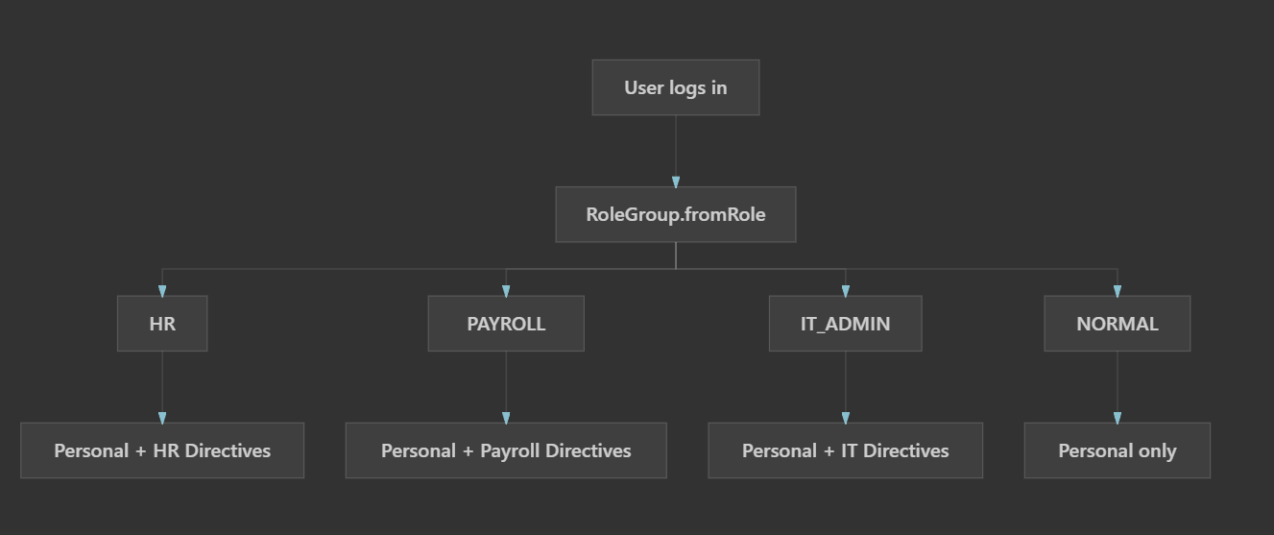

8. Design patterns and OOP themes
Pattern / principle | Where it appears
Layered architecture | ui / service / repository / model
Repository | I*Repository + JDBC implementations (CSV legacy)
Template method | AbstractCsvListRepository (CSV), AbstractJdbcRepository (JDBC, planned)
Transaction boundary | Batch save + finalize period (provisional)
Dependency injection (manual) | ApplicationContext composition root
Interface segregation | IEmployeeService, IAttendanceService, etc.
Strategy / polymorphism | ModuleScreen — Main opens any module uniformly
Abstract base class | AbstractEntity, BaseModuleScreen
Factory | RoleGroup.fromRole(String)
DTO / value object | PayrollResult, AuthContext, PayrollData
Utility / facade | InputFilters, validation utils, PayrollUtils

Coursework Javadoc tags ([ABSTRACTION], [POLYMORPHISM], [INHERITANCE], [ENCAPSULATION], [INTERFACE]) mark intentional OOP teaching points throughout the source.

12. Boundaries and limitations

- Single-user desktop: Still one Swing process; MySQL provides a shared source of truth but we have not designed multi-user locking in the UI.
- MySQL required (target): Application needs a running MySQL instance and connection configuration (credentials not stored in repo).
- Migration: CSV seed import strategy and schema details are provisional (see section 16).
- No formal build tool in-repo: compile/run from IDE with src as source root.
- Legacy CSV: csv/ remains for seed/fallback; relative paths assume project root as working directory.
- IT ticket repository: ApplicationContext can fall back to a no-op IItTicketRepository if ticket repo fails to load (defensive bootstrap).
- Testing: No automated test suite; behavior validated manually through the Swing UI.
- Current code gap: Repository layer in src is still CSV-only until JDBC implementation milestone.

